Breadboard Prototype

Personal Health Monitor

Jean-Sebastien Pivin

Student No. 1055840

Final Project I

Presented to: Marc Fricker

November 22, 2017

Table of Contents

Table of Figures 2

Introduction 3

Body Temperature Sensor 3

Pulse Rate Sensor 5

# Table of Figures

Figure 1: Body Temperature Sensor Circuit 3

Figure 2: Body Temperature Test Code 4

Figure 3: Body Temperature Sensor Results 5

Figure 4: Pulse Rate Monitor Circuit 6

Figure 5: Pulse Rate Monitor Test 6

# Introduction

This document serves the purpose of demonstrating the functionality of received components to show they will be viable for the project. For the Personal Health Monitor project, three sensors will be present. There will be a thermistor to measure the body temperature, a red LED and phototransistor to measure the pulse rate and blood volume in the finger as well as electrodes to measure the heart rate. The temperature sensor was fully built and tested on a breadboard. The pulse rate monitor was also built on a breadboard and tested. The heart rate monitor will be similar to the pulse rate monitor where is will measure voltage changes. For this document, since the electrodes were not received yet, the heart rate monitor was not built or tested but since it will measure voltage changes as the heart beats, it will be a similar sensor to the pulse rate sensor. The body temperature and pulse rate sensor will be discussed in further detail below. Note the microcontroller being used for this project and tests in the Arduino MKRZERO.

# Body Temperature Sensor

The body temperature sensor circuit can be found below in Figure 1. This circuit is composed of a 10kohm resistor, a 10kohm thermistor and a OPA344 op-amp. Originally, the circuit had no op-amp but after a few tests, the voltage being read by the microcontroller was incorrect to what the theoretical value should be. The voltage being read by the microcontroller is where the resistor and thermistor meet, thus creating a simple voltage divider. Since both components are rated for 10kohm the voltage read should have been close to 1.6V (3.3/2). In reality it was reading 2V. Therefore, the op-amp was added creates a buffer which removes the loading effect from the microcontroller.

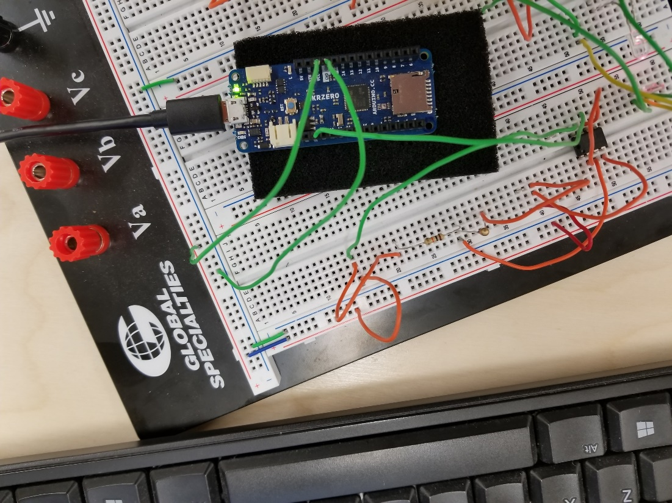

Figure : Body Temperature Sensor Circuit

After this modification was done, the correct voltage was being read and thus the correct temperature was calculated and displayed on the serial monitor. The code for the test can be found below in Figure 2. It was derived from a lab done in the Micro II course.

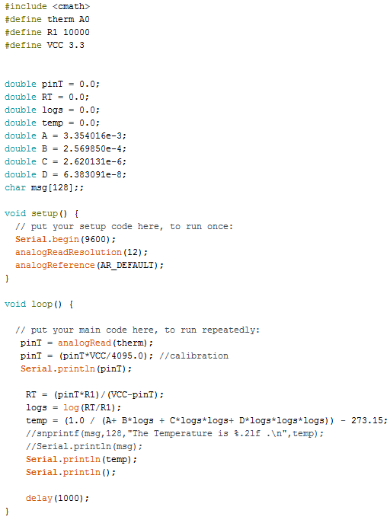

Figure : Body Temperature Test Code

To demonstrate functionality, the results of the voltage being read and temperature were printed on the serial monitor. This can be seen in Figure 3. For the purpose of this test, the thermistor was held with 2 fingers for roughly 10 seconds to reduce the amount of readings. But as seen below, the sensor measures room temperature and increases when touched with 2 fingers since body temperature is greater than room temperature. Voltage read at test point is being shown above the temperature reading.

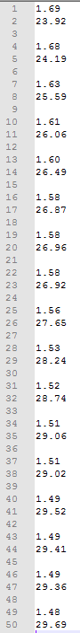

Figure : Body Temperature Sensor Results

# Pulse Rate Sensor

The second sensor built was the pulse rate sensor. This is composed of a red LED, phototransistor as well was op-amps with capacitors and resistors that create amplifiers and filters. The circuit for the pulse rate monitor can be seen below in Figure 4. This sensor is essentially measuring the change in voltage resulting from blood volume in the finger. The circuit was built starting with only the LED and phototransistor. Then the filters and amplifiers were built one by one and checking their output signals. No code written as time was an issue after building the circuit and testing with the oscilloscope.

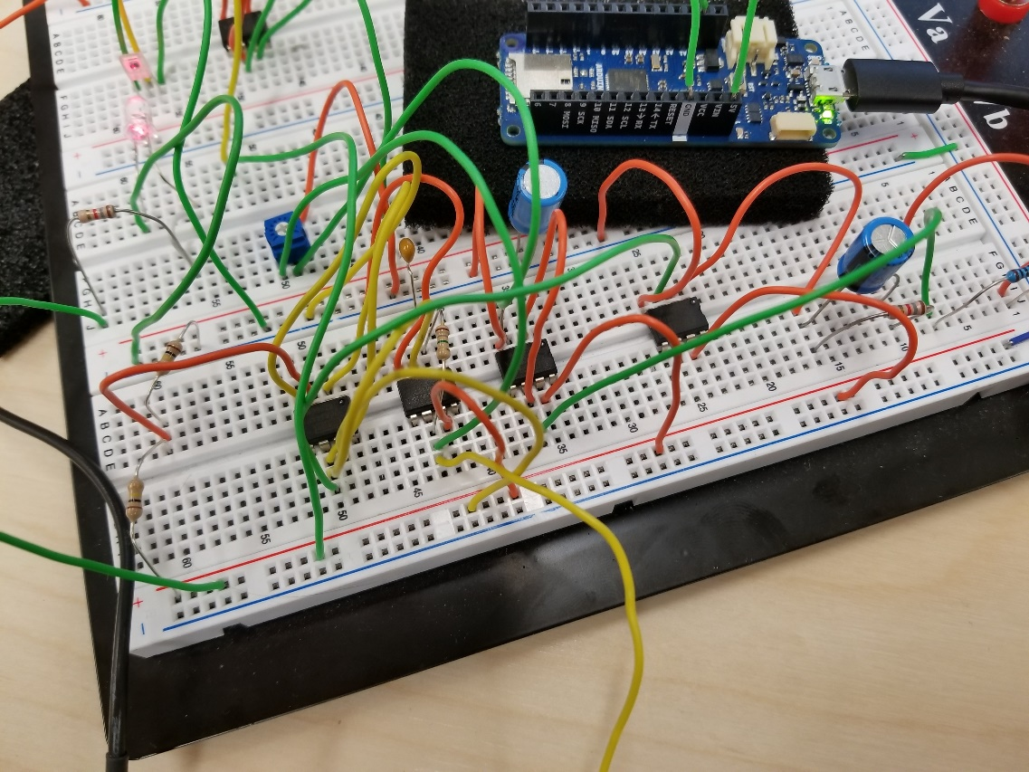

Figure : Pulse Rate Monitor Circuit

The resulting output signal measured from the oscilloscope can be seen below in Figure 5. The waveform seen is the varying amounts of blood in the finger caused by heartbeats. The peaks are at different heights since phototransistor is loose in the breadboard. Further testing needs to be done with finger clip.

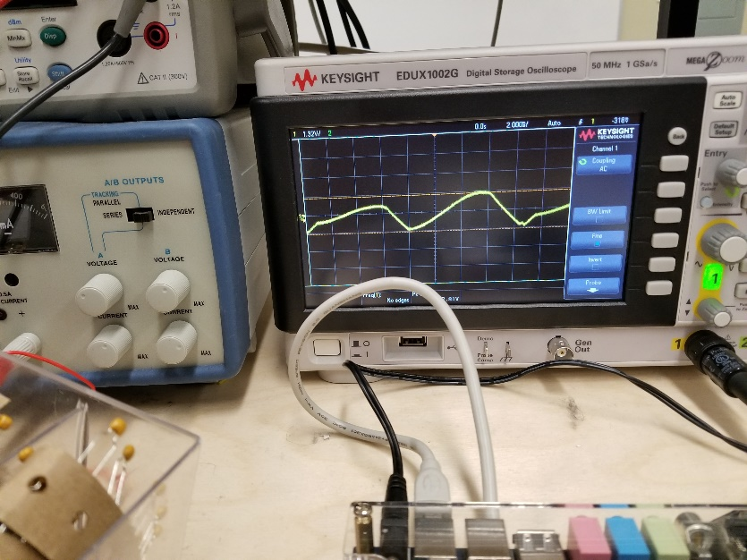

Figure : Pulse Rate Monitor Test